<https://coin98.net/what-is-retroactive-airdrop>

# What is Retroactive Airdrop? The best returns with minimal investment

Published Nov 8, 2021

Charlie

00:00/ 00:00

Female



What is Retroactive Airdrop? Why is Retroactive Airdrop used? How to find potential projects that will distribute Retroactive Airdrop rewards?

## What is Retroactive Airdrop?

Retroactive Airdrop is the event that **distributes tokens** to investors, supporters, users, and adopters who went with the projects in the early days. Projects’ distributed tokens are completely free to earn for everyone who contributed to the projects.

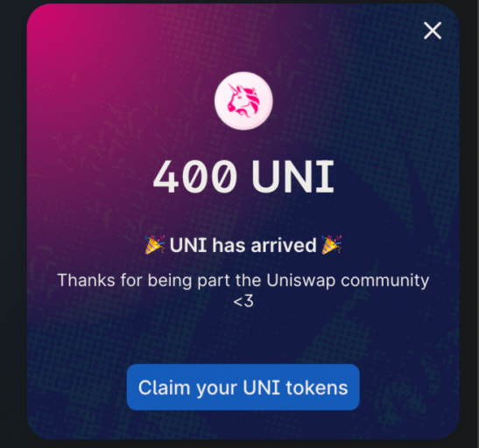Uniswap Retroactive Airdrop

To earn Retroactive Airdrop rewards, users need to meet some specific requirements from the token distributing project. For example, for DEXs, users should **provide liquidity, conduct swap transactions, interact with every feature** of the project, etc. to earn Retroactive rewards later as tokens of the project.

The term Retroactive Airdrop has been widely used since the Retroactive token airdrop of Uniswap. The largest DEX on Ethereum announced that every early user of the platform (the snapshot was taken before Jan 9th, 2020) was rewarded with 400 UNI tokens at least. Some users earned millions of dollars through this massive Retroactive program of Uniswap.

## 3 biggest Retroactive Airdrop in the Crypto space

### Uniswap

[**Uniswap**](https://coin98.net/uniswap-uni)is the largest AMM DEX built on Ethereum with a market cap of over $16B. On Sep 17th, 2020, Uniswap announced that it would distribute tokens (15% of the UNI total supply) to its early users via the Retroactive airdrop.

Uniswap Retroactive Airdrop

Every wallet that met the requirements would receive at least 400 UNI (equal to $2,000 at that time). After the announcement, the UNI token was listed on Binance, Coinbase, etc. increasing the UNI price by over 100%. This event is the beginning of the Retroactive surge.

### 1Inch

[**1Inch**](https://coin98.net/what-is-1inch)is the competitor of Uniswap that also announced the Retroactive program in 2020 - 2021 as follows:

* 4.8M 1INCH were distributed to over 9,000 Mooniswap users, meaning that they would receive about 500 1INCH (equal to $3,000 at that time).
* 3.57M 1INCH for over 1,300 users who had participated in liquidity mining on the platform since Nov 2020.
* 685,000 1INCH for users who interacted with Argent, Authereum, Gnosis, and Pilnar.

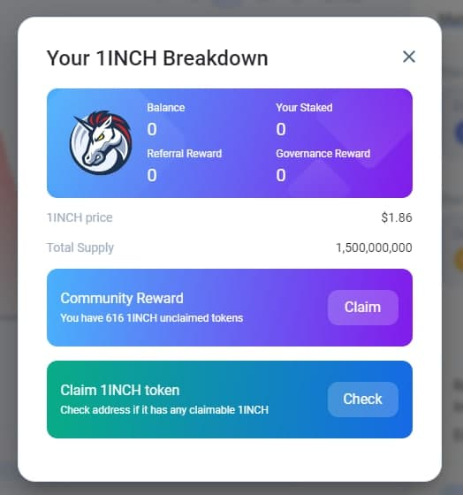1Inch Retroactive Airdrop

Furthermore, 1Inch Exchange distributed 6M 1INCH to Uniswap users. To be rewarded, users needed to interact with Uniswap for at least 20 days, conduct at least 3 transactions in 2021 and have no interaction with 1Inch Exchange and Mooniswap. According to 1inch Exchange, over 25,000 eligible wallets receive 240 1INCH tokens (equal to $1,350 at that time).

The total number of 1INCH distributed in the Retroactive program was over 15M tokens.

### dYdX

If **[dYdX](https://coin98.net/what-is-dydx" \t "_blank)**is not mentioned in the article, it will be an incomplete one. dYdX has released the biggest Retroactive program distributing 7.5% of the DYDX token total supply (75,000,000 DYDX). The total value of the airdrop was nearly $1B at that time.

The program would send DYDX to users who interacted with the platform corresponding to their contributed trading volume:

* 310 DYDX to users who contributed at least $1 trading volume.
* 9,529 DYDX to users who contributed over $1M trading volume.

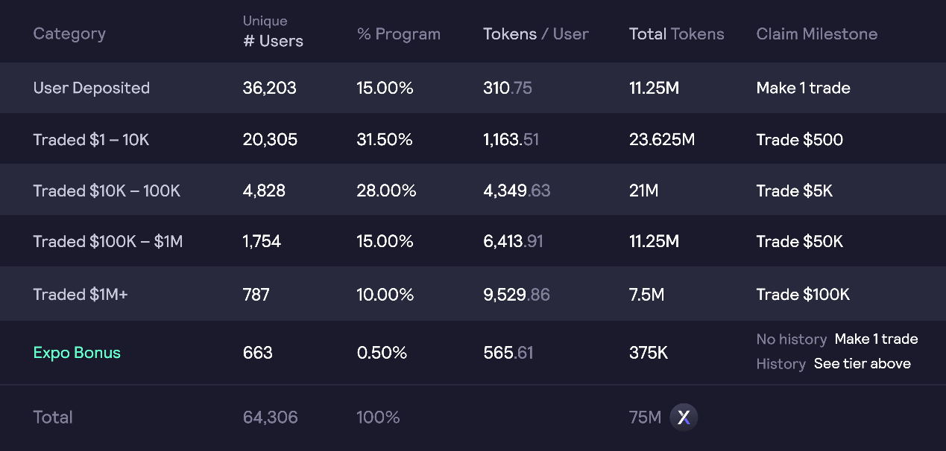

## Why is Retroactive Airdrop used?

### To reward early users who contributed to the project

From the dawn of the crypto world, some investors have been looking for a quick-rich scheme with an unbelievable [**ROI**](https://en.wikipedia.org/wiki/Return_on_investment)in the short term disregarding the value of the project in the long term. They hop in and out quickly after slight volatility. From the perspective of the project, they want investors to hold tokens to accompany them for a long-term target.

Therefore, to incentivize investors to actively use the platform and support the project, they will release the Retroactive program. However, the airdrop announcement is often not released in advance, creating a surprising factor for investors.

### A wonderful means of marketing

Some projects successfully draw attention from the community after releasing the Retroactive programs. Such as mentioned projects (Uniswap, 1Inch, dYdX, etc.) created a hype of Retroactive, causing investors to actively hunt for it on other platforms.

Retroactive raises the awareness of users for the DeFi products as well as the features of one project. This attracts more users to come to the platform and builds the community surrounding the project. Everyone loves easy money, especially Retroactive airdrops.

### Attract and draw users from other projects

The crypto world itself is a very competitive market, everyday new projects are released and they need to build up a new user base from zero. Airdrop is an effective method to attract new users to try the products and join the community.

Like other incentive programs (liquidity mining, staking rewards, etc.), Retroactive airdrop is the strategy that can leverage the media and free marketing since everyone loves free (sometimes big) rewards.

## How to find potential projects that will distribute Retroactive Airdrop rewards?

### Projects without token release

Every blockchain ecosystem consists of multiple different sectors such as DEX, Lending, Derivative, Payment, NFT, etc. We can categorize them and look for the projects which haven’t released their tokens. Then we can **compare to its competitors in the same category** so that we can estimate, assess and have some assumptions about the potential of Retroactive.

For example, Uniswap, Sushiswap, PancakeSwap,... are AMM DEXs that released their tokens. Uniswap and 1inch Exchange announced the Retroactive program. Therefore, we can look for projects that are competing with those DEX giants.

**Perpetual Protocol and dYdX**are the biggest decentralized derivatives platforms that have recently released the Retroactive program for early users. We can look for similar derivatives platforms on other more technology-advanced blockchain platforms. Then we should interact with all available features and contribute to the trading volume.

We can list some questions/queries while looking for potential projects:

* How long have those projects been operating without releasing tokens?
* How big is the community and is it supportive?
* What are the reasons for the investment decision? Is it good enough?

### Projects with positive revenue

Revenue is the best metric to measure the performance of one project since it reflects the effectiveness of a profitable one. **Projects with high revenue will have a higher chance to release Retroactive rewards to their early users**.

For example, after the Retroactive airdrop for users in 2020, 1inch Exchange continued to announce the airdrop for Uniswap users in 2021.

Therefore, users are looking forward to receiving airdrop from projects without token release but with revenue. The value of the airdrop is often massive since the revenue contributes lots of additional value to the airdrop. We can name projects with high revenue having released massive airdrops: dYdX, Uniswap, 1inch Exchange, etc.

### Projects launched Testnet or need feedback from users

Projects that have launched Testnet/Product Beta often announce airdrop programs to incentivize users to interact with the platform to find out bugs, exploits, etc.

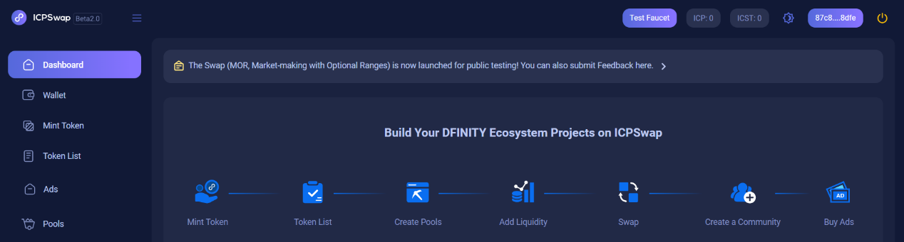ICPSwap Testnet feedback

We should regularly keep an eye on **social media of projects** such as Twitter, Facebook, Telegram, Discord, etc. in order not to miss any news.

Furthermore, the growing number of Testnet/Beta users is the applicable metric for the developer team to measure how the community embraces their products. Therefore, the team can change and improve the platform before the mainnet release.

### Follow the cash flow

Locating **where the cash flow is going** is a way to access a potential investment opportunity. Especially, let’s notice new emerging ecosystems that don’t receive much attention from the community. When the whole ecosystem is developing rapidly as well as the projects. They want to attract new users, build the community and gain a reputation as fast as possible, then the airdrop or reward distribution might be the most proper solution.

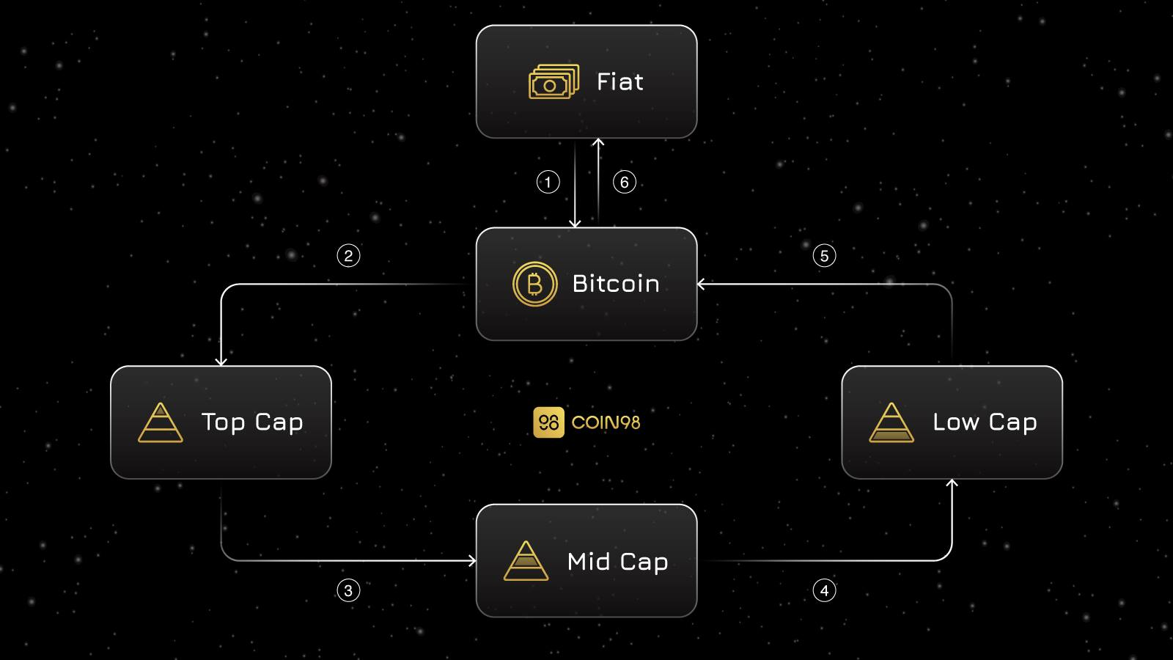The Cash Flow Model

For example, Solana and its ecosystem have been developing incredibly fast in 2021. Multiple incentive programs to accelerate the ecosystem growth were released. There are some Solana-based projects that released the Retroactive airdrop to users such as Orca, Port Finance, Solend, etc.

For example, [**Orca**](https://coin98.net/what-is-orca-token)distributed an airdrop with over 5M ORCA (5% of the total supply).

***See Also:***[***Solana Ecosystem Overview***](https://coin98.net/solana-ecosystem)

### Follow the news and updates about upcoming airdrops

Besides categorization and filtration of potential projects, there are some websites that regularly update the information of airdrop for users as follows:

* [Etherscan Airdrop](https://etherscan.io/airdrops): All potential airdrop on Ethereum.
* [AirdropAlert.com](https://twitter.com/Airdropalertcom): Airdrop scan on Twitter and Bitcoin forums.
* [Coinairdrops.com](https://coinairdrops.com/): All information about hottest airdrops.
* [Defillama](https://defillama.com/airdrops): All potential airdrops that are sorted by blockchain platforms.

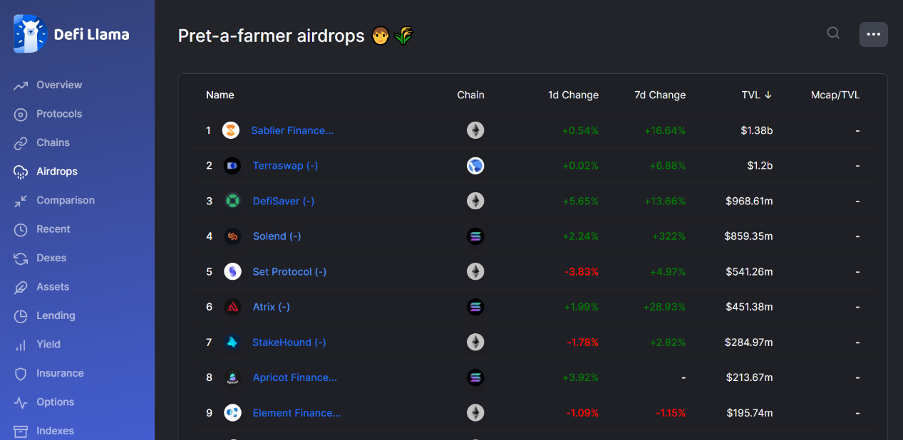Airdrop Information

* [Darren Lau (Lau, Lau)](https://twitter.com/Darrenlautf): This Twitter often shares information about Retroactive programs. He has a Telegram channel that publishes a newsletter daily.

Darren Lau

Every airdrop is worth participating in, but sometimes things are not as we expect. The following headline will introduce us to what we should prepare for the airdrop.

## Airdrop hunting preparation

### Psychological Preparation

Retroactive Airdrop can give you a massive return on your little investment. However, the Retroactive rewards will not come immediately when you’re doing the interaction. It can be years for a big airdrop, causing airdrop hunters frustrated and impatient.

The project team will decide whether a Retroactive airdrop will be released, not depending on you. Therefore, nothing can guarantee a future airdrop that can happen. Therefore, we should prepare our mindset that **we might or might not receive the airdrop**.

When you’re looking for airdrops from projects that often are in the early stages of development. As a result, keep in mind that you can risk your funds while you interact with the platforms. To avoid damages from rug-pull, scam, untrustful projects, **you should invest the funds that you’re willing to lose**.

### Quick Assessment for Projects

Before participating in interacting with the platform to earn airdrops, we should do research on the project, affecting the chance of success of that airdrop. There are keynotes for airdrop hunting as follows.

**The newer the project, the higher chance we get.**The project receives little attention from the community, shown by the number of followers on Twitter, Facebook, Telegram, Discord, etc. The fewer participants, the higher chance we get the airdrop.

**The more difficult the airdrop, the fewer participants will join it.**Airdrop participants need to go through many steps to complete the requirements. The project targets users who are willing to accompany in the long term.

For example, dYdX required users to deposit on the layer-2 product of Starkware, then contribute a sufficient amount of trading volume. To earn the big airdrop from dYdX, users had to interact with all features of the platform.

The strict requirements will deter impatient users so that other users will have a higher chance of getting the airdrop. Furthermore, users can try more blockchain-based products, enhancing their knowledge about the crypto world.

## What is needed to earn the airdrop?

In general, receiving airdrops is getting more difficult over time since the number of users looking for them is growing constantly. The airdrop reward will be distributed to every eligible user who contributed to the project. Therefore, the more users, the smaller the reward will be.

**The requirements of getting the airdrop are very flexible**, depending on the aim of the project. However, to earn airdrop, users should interact with every feature and product on the platform to get a higher chance of being airdropped.

According to the distributed airdrops from Uniswap, Solend, dYdX, etc. we can give some common interactions that can lead us to the airdrop.

**AMM DEX (Uniswap, 1inch, Ref Finance, etc.):**Users should trade/swap multiple times to increase the trading volume, provide liquidity or participate in yield farming programs.

For example, [**Ref Finance**](https://coin98.net/what-is-ref-finance) distributed the airdrop to its users who swapped 7 times or provided liquidity 3 times on the platform.

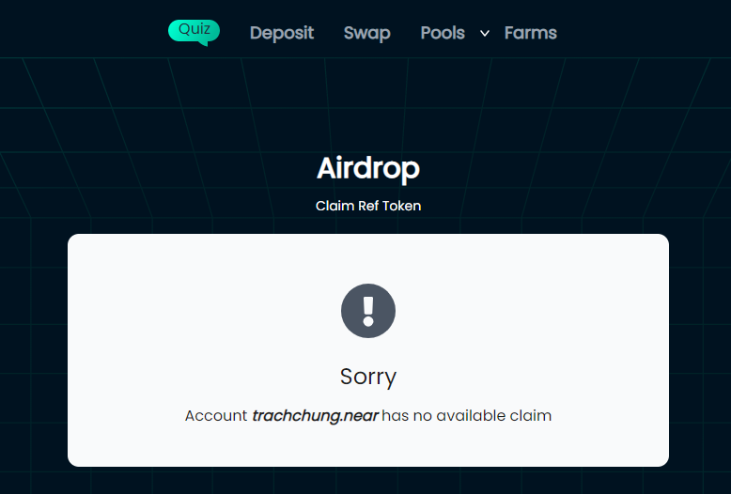I did not have enough swap trades on the Ref Finance platform so I wasn’t eligible for the airdrop

⇒ We should interact as many times as we can. Nobody can know the specific requirements.

**Lending/Borrowing platforms (Solend, etc.):** Users should deposit/supply tokens and borrow tokens on the platform for a period of time.

For example, **[Solend](https://coin98insights.com/what-is-solend-slnd" \t "_blank)**is a lending platform that distributes its SLND tokens to users as Retroactive rewards. To earn this, users needed to supply/borrow tokens on the platform then the project will calculate the Retroactive airdrop for each user corresponding to their contribution.

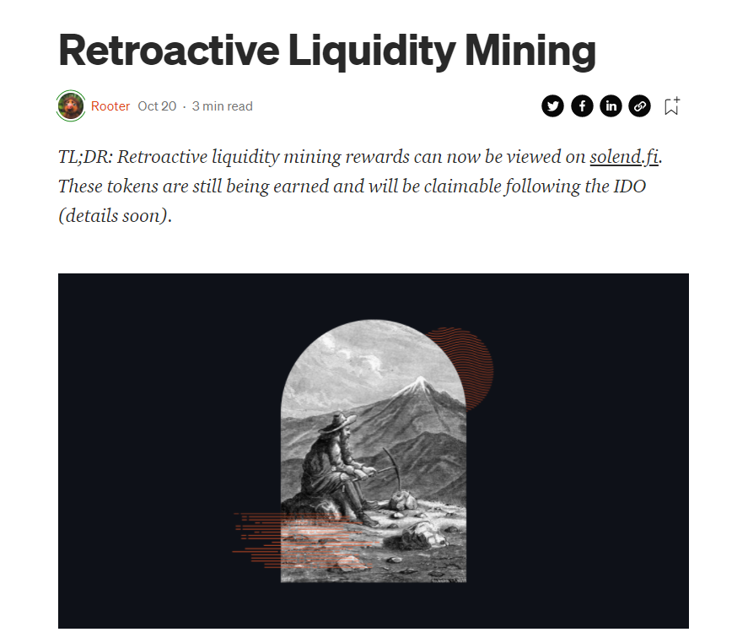Solend Retroactive Program

**NFT platforms:** Users should trade/sell/mint NFTs on the platform to increase the trading volume.

## Risks when participating in a potential airdrop

* **Losing funds:**When interacting with the platform, users have to pay the gas fee, the platform fee, and sometimes the price slippage. This will add up to a considerable number of crypto losses while users repeatedly interact with the platform.
* **Time:** Users will have to spend a considerable amount of time interacting with the features of the platform. Especially, the project Testnet has technical problems, making users troublesome. Furthermore, users need to wait for the airdrop that might not happen.
* **Scam/fraudulent projects:** Scammers can use the airdrop as an attractive bait to lure investors to deposit/connect their funds to the scam platform. Therefore, we should invest in a fund that we’re willing to lose in case the worst scenario happens.

## Conclusion

The Retroactive airdrop could sometimes surprise us with a massive return if we did it right. It can change and leverage one’s position in the crypto world. The benefit of Retroactive to users and the project is huge but we should be selective for potential projects.

And that is all you need to know about Retroactive. We hope your work looking for Retroactive will pay off. In the next articles, Coin98 will list potential projects that might launch Retroactive airdrop for users.